**Flink Code Development & CI pipeline**

Reference: <https://github.ibm.com/rashaik4/flink-poc>

<https://ci.apache.org/projects/flink/flink-docs-stable/getting-started/tutorials/local_setup.html>

<https://github.com/apache/flink/tree/master/flink-examples/flink-examples-streaming/src/main/java/org/apache/flink/streaming/examples/wordcount>

<https://mkyong.com/maven/how-to-create-a-jar-file-with-maven/>

Refer <https://github.ibm.com/whc-toolchain/whc-worker-app-1> for CICD pipeline

* Code Structure

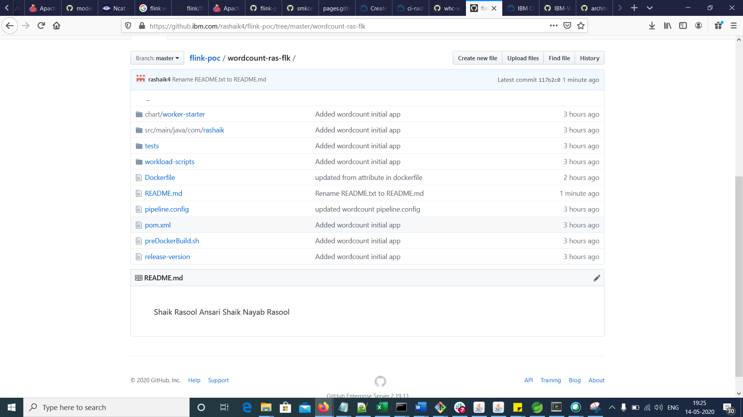

* Pom.xml
* The pom.xml should have maven-jar-plugin and maven-dependency-plugin
* I need to check with maven-shade-plugin, instead of above two plugins

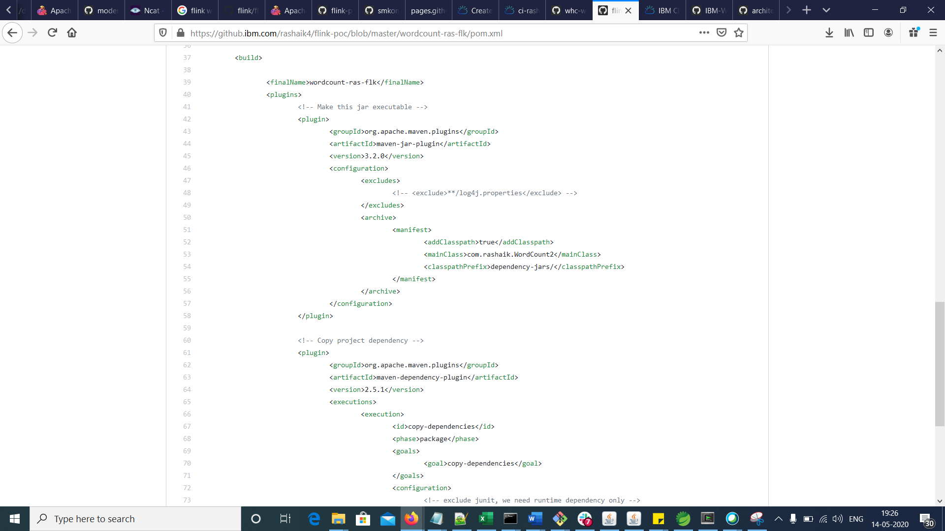

**Run application locally**

* Execute the application like Java application
* Execute “mvn clean package” to build the application, then run “java -jar <application.jar>” to execute it on command prompt.
* You should get the same response from both the above ways.

**Run application as Flink job on cluster**

* Submit the jar as a new job

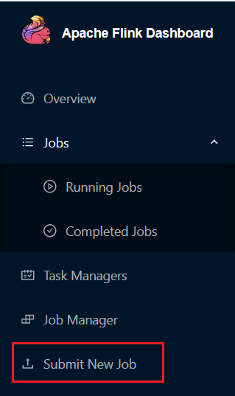

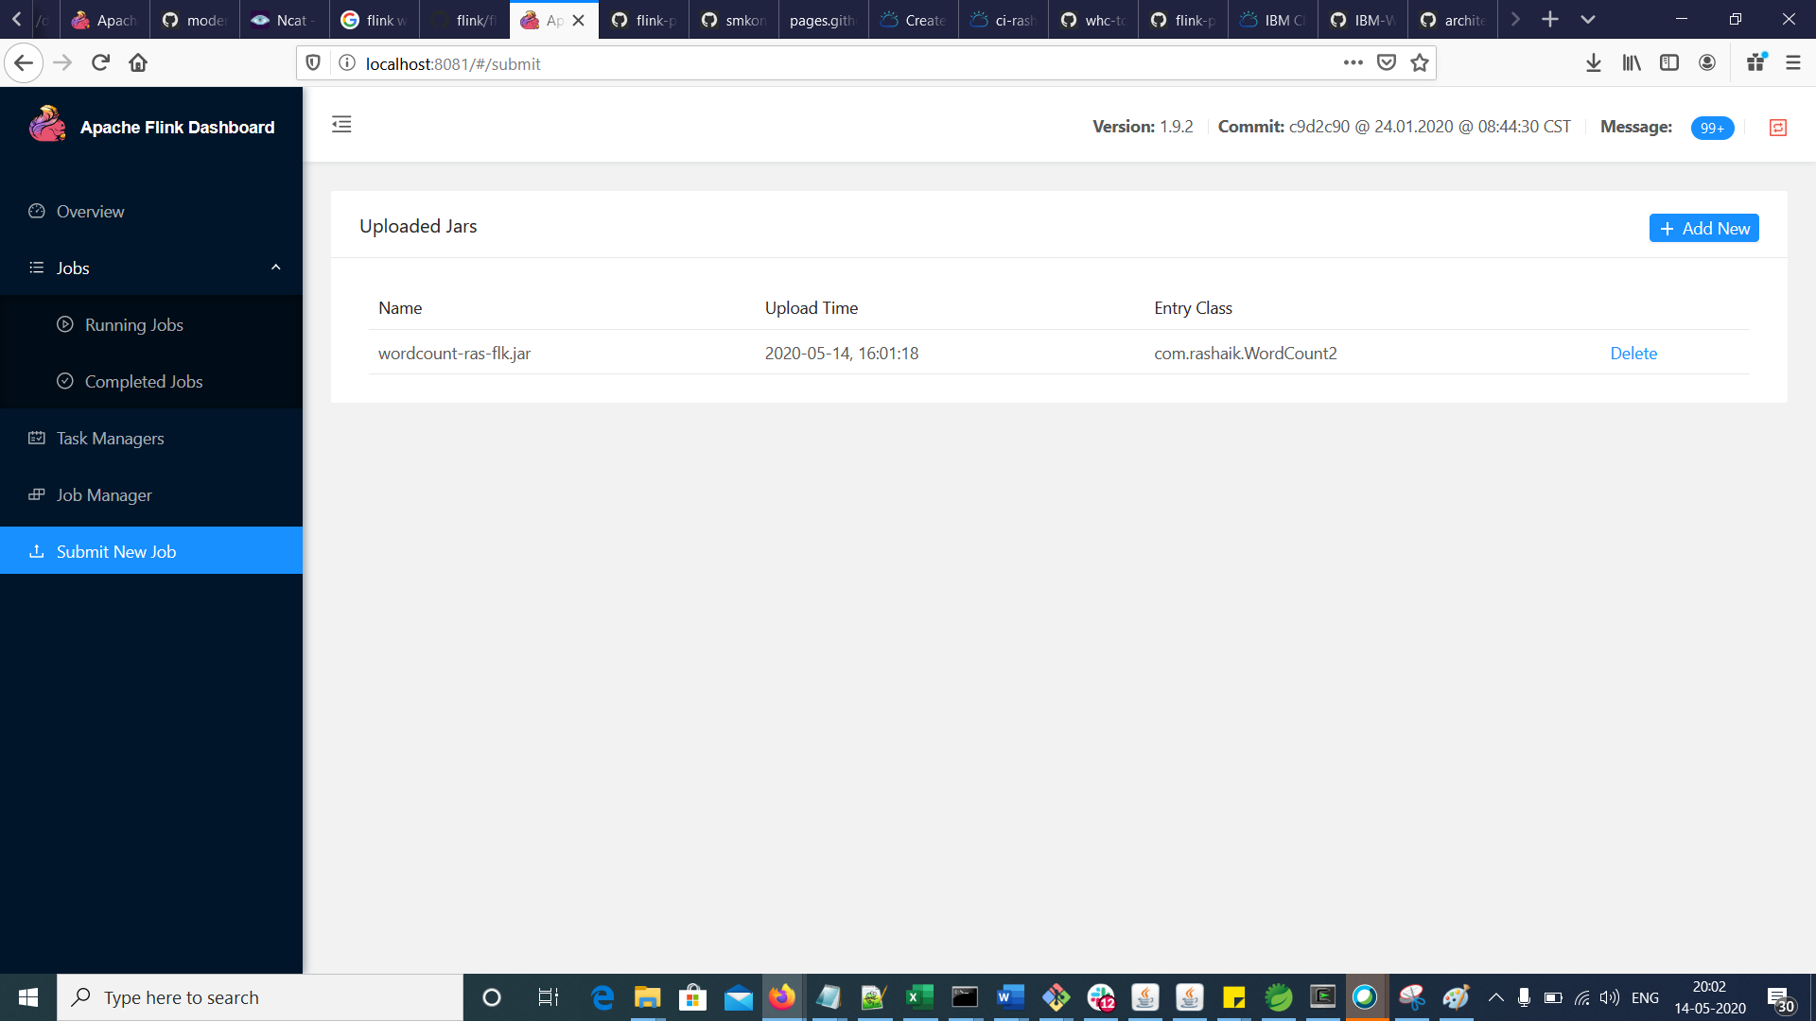

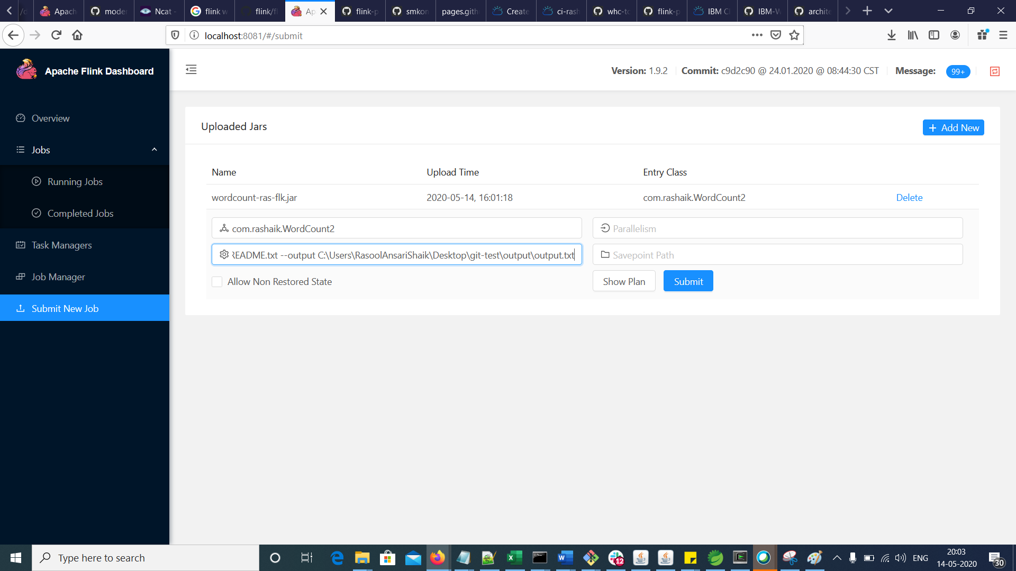

--input C:\Users\RasoolAnsariShaik\Desktop\git-test\input\README.txt --output C:\Users\RasoolAnsariShaik\Desktop\git-test\output\output.txt

Click on “Submit” button.

**Use the repo to complete CICD pipeline using stable-208 template**

* Refer below CI pipeline

<https://cloud.ibm.com/devops/pipelines/a8d2f914-aa5e-492c-847a-844db950b156?env_id=ibm:yp:us-south>

* In Pre-Docker Build stage, update job build script by adding below command

cp -R wordcount-ras-flk/* ./

This is required because of my Git repo structure

* Refer the Github repo and CICD reference repo to build the required files and CI pipeline

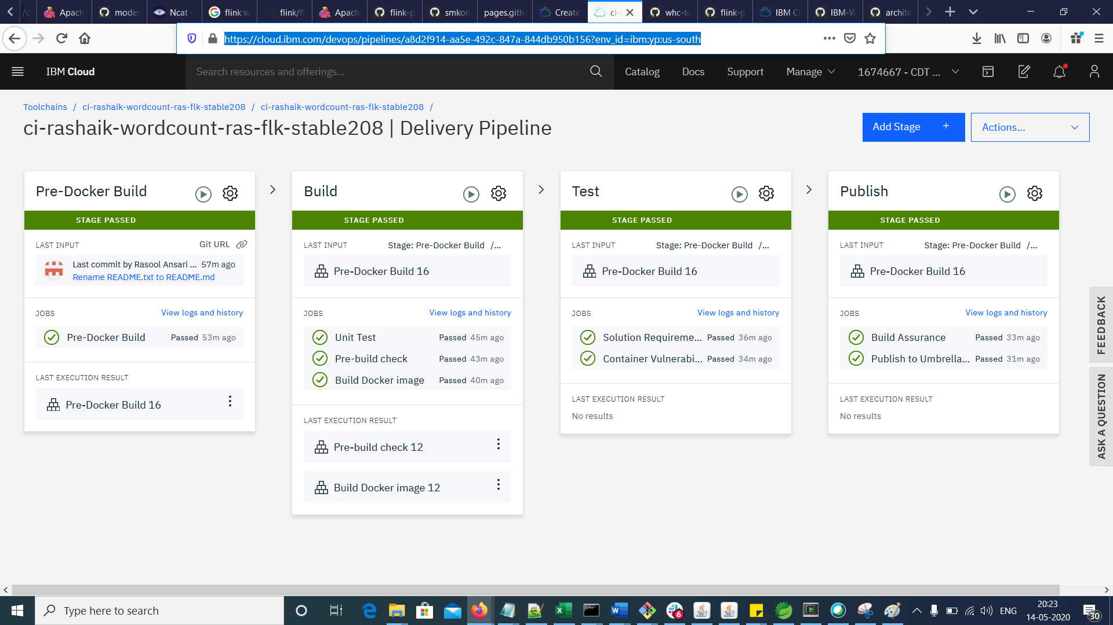

Refer Umbrella repo: <https://github.ibm.com/modern-poc/k8s-cdt-umbrella>

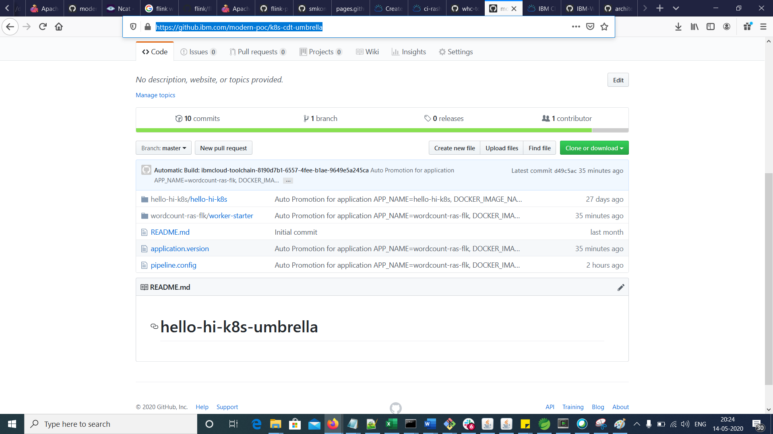

* For insights dashboard

Refer: <https://cloud.ibm.com/devops/insights/qualitydashboardNew?toolchainId=533394ae-9e05-4ae7-9d18-2d3e994a2264>

